新竹市新科國中114學年度第二學期國中七年級英語補考題庫
班級： 姓名： 座號：
- 單題
1.(A) Teacher Jeff cut the pizza into six pieces and _________ to each of us.
(A) gave (B) gives (C) give (D) is giving
2.(C) What _________ to Jerry yesterday morning? He didn’t come to school.
(A) did happen (B) was happen (C) happened (D) was happening
3.(A) Tina _________ a story book with her mom last night.
(A) read (B) reads (C) readed (D) reading
4.(D) Henry _________ four bowls of rice _________ he was very hungry.
(A) eats; but (B) eat; or (C) ate; so (D) ate; because
5.(D) Kelly _________ for two hours every day last year. Now, she _________ for one hour every day.
(A) swims / ran (B) swims / runs (C) swam / ran (D) swam / runs
6.(B) Was Laura a doctor _________?
(A) ago (B) before (C) now (D) ten years
7.(A) A: Did they _________ English yesterday? B: Yes, they did.
(A) study (B) studies (C) studied (D) studying
8.(C) A: Were you a student here? B:_________________
(A) Yes, we are. (B) Yes, we were. (C) Yes, I was. (D) Yes, I were.
9.(B) Lily: Who _________ five minutes ago? Mia: I helped Nancy.
(A) helped you (B) did you help (C) didn’t you help (D) needed help

第1頁，共6頁
10.(C) Tom:________________________________
John: He gave me a new watch.
(A) When did Mr. John give you the watch?
(B) Did Mr. John give you a gift?
(C) What did Mr. John give you?
(D) Why did Mr. John give you the watch?
（11~13）
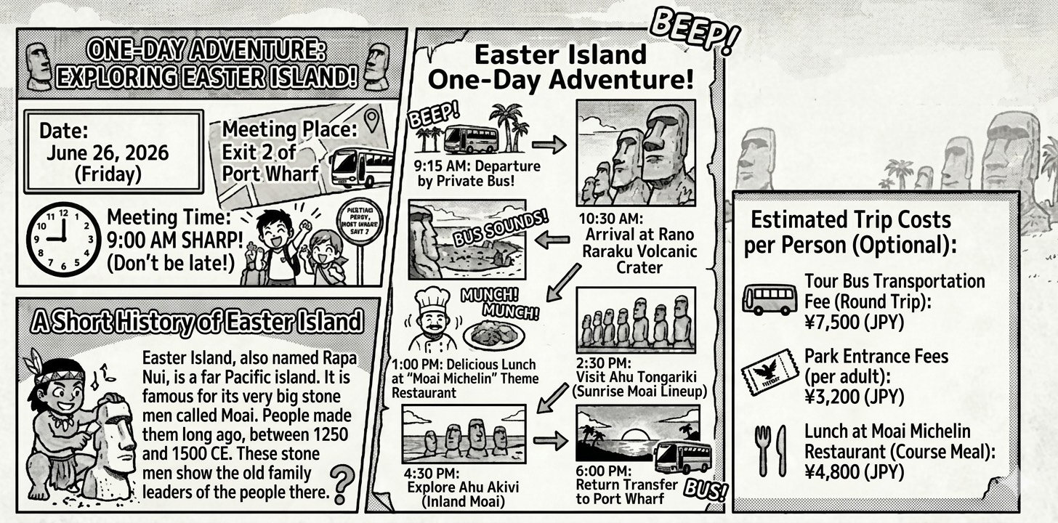
port wharf港口碼頭 departure起程 private私人的 explore探索 round trip來回旅程 course 一道菜

11.(D) If an adult joins this one-day tour and chooses to have the course meal for lunch, how much
will the total cost be?
(A) ¥12,000
(B) ¥10,700
(C) ¥7,500
(D) ¥15,500

第2頁，共6頁
12.(B) Where will the group go after they finish their lunch at the theme restaurant?
(A) Rano Raraku Volcanic Crater.
(B) Ahu Tongariki.
(C) Port Wharf.
(D) Ahu Akivi.
13.(C) Which of the followings about the trip is TRUE?
(A) Ahu Tongariki is a place to see the sunset with Moai.
(B) The tour is held on a weekend in June 2026.
(C) People can see ‘Inland Moai’ at Ahu Akivi.
(D) The meeting place is at Exit 1 of Port Wharf.
(14~16)
Sagrada Família: A Church That Is Still Becoming
The Sagrada Família in Barcelona is a very special church. It looks unique, and it has a very long history. People started to build this church in 1882. Today, more than one hundred years later, it is still not finished.
Antoni Gaudí was the designer of the church. He believed that buildings should look like nature. Because of this, he used many shapes from plants and trees in his design. Gaudí also knew that the church would take a very long time to build. He once said that his "boss" was not a person, but God. This meant he did not need to hurry.
After Gaudí died, some people thought the building work would stop. However, the work continued very slowly. Wars in Spain and a lack of money made the church stop many times. For some years, people could only build a very small part of it.
But in recent years, things have changed. Many tourists come to visit the church and give money to help. Also, modern computers help workers understand Gaudí’s difficult ideas more easily. However, some people still argue whether the new parts look the same as Gaudí's first plan.
Today, people think the Sagrada Família will be finished in a few years, but no one is 100% sure. Some people even believe that being "not finished" is the most special thing about this church.
unique獨特的 lack缺乏 argue 爭論 whether是否 technical科技的

第3頁，共6頁
14. (B) What is the main idea of the first paragraph（段落）?
(A) To explain why the church is famous
(B) To introduce the long and unusual building history
(C) To describe Barcelona tourism
(D) To show Gaudí’s personal life
15. (C) What is NOT mentioned as a reason for running late?
(A) War
(B) short of money
(C) Weather problems
(D) Technical difficulties
16.(B) What does the last sentence suggest（暗示）?
(A) The church should never be finished
(B) The unfinished church may be meaningful itself
(C) That the building failed is important
(D) The church is no longer important
三、Cloze (17~20)

Palm Oil Farms in Indonesia and the Taj Mahal in India
Last week, Ms. Hsu gave her students a lesson about how human activities can change both nature and culture in Asia. First, she 17 that Indonesia once had large areas of tropical rainforest. However, many of these forests turned into palm tree farms. Today, there 18 many palm trees in the large areas of land, which has greatly changed the environment and affected wildlife.
Then, Ms. Hsu moved on to Taj Mahal in India. She explained that the Taj Mahal 19 one of the most beautiful buildings in the world. It was built in the 17th century by Emperor Shah Jahan in memory of his wife. She also added that millions of tourists 20 the Taj Mahal every year, making it one of the most popular historical sites in Asia.
17.(D) (A) says (B) sayed (C) is saying (D) said
18.(A) (A) are (B) have (C) had (D) was
19.(A) (A) is (B) was (C) are (D) be
20.(C) (A) visited (B) visits (C) visit (D) visiting

第4頁，共6頁
(21~25)
Last summer, Amy took a trip to a famous forest in the south of the country. She went there with her uncle. They stayed at a small hotel near the forest. The hotel was very old, but the people there were warm and kind. On their first day, Amy and her uncle __21__ a long walk in the forest. The trees were very tall and beautiful. Amy wanted to know their age, so she asked a local woman. The woman said, "These trees are about 800 years old. A long time ago, a king __22__ a lot of trees here because he lost his wife. The trees were her favorite." Amy was surprised. She said, "__23__ ?" The woman smiled and answered, "He buried her under the biggest tree over there." Amy looked at the big tree and felt sad for the king. That evening, Amy __24__ to her mom about the story. Her mom said, "What a sad but beautiful story!" Amy agreed. She __25__ her trip to the forest for a long time.
local 當地人 buried 埋葬（bury 的過去式）

21. (A) (A) took (B) take (C) takes (D) taking
22. (B) (A) plants (B) planted (C) is planting (D) plant
23. (C)
(A) How old is she (B) Where did she live
(C) Where did the king bury his wife (D) How did the king lose his wife
24. (C) (A) talks (B) talk (C) talked (D) is talking
25. (C) (A) forgets (B) forgot (C) won’t forget (D) forget
(26~30)
Patty is a student from Taipei. Last month, she took a trip to New York __26__ ten days. It was her first time there. She felt very excited! On her second day, she went to Times Square and Central Park. She __27__ a walk in the park and enjoyed the beautiful sights. On the third day, she visited the Statue of Liberty. It was amazing. She took a lot of pictures there. However, the weather __28__ very cold that day. Patty didn't bring a warm coat, so she __29__ a jacket at a shop near the hotel. She said, " __30__ !" Her trip to New York was a great memory.
Statue of Liberty 自由女神像 sight 景色 memory 回憶

26. (C) (A) in (B) at (C) for (D) on
27. (B) (A) take (B) took (C) takes (D) is taking
28. (D) (A) is (B) are (C) were (D) was
29. (C) (A) buys (B) buy (C) bought (D) is buying
第5頁，共6頁
30. (C) (A) forgets (B) forgot (C) won’t forget (D) forget

第6頁，共6頁

