八年 班 座號： 姓名：
- 字彙選擇 (60%)
- (A) Look at the picture. What is the man doing?
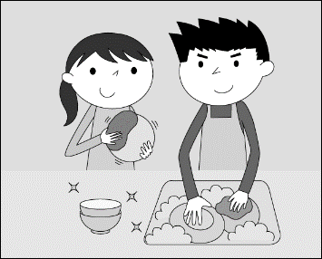
(Ａ) He is doing the dishes.
(Ｂ) He is fixing the drawers.
(Ｃ) He is taking out the trash.
(Ｄ) He is wiping the windows.

- (D) Look at the picture. What season is it?
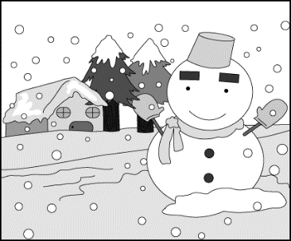
(Ａ) Spring.
(Ｂ) Summer.
(Ｃ) Autumn.
(Ｄ) Winter.

- (C) Look at the picture. What will the girl do tomorrow?
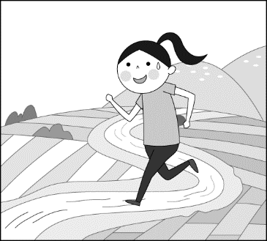
(Ａ) She will go biking.
(Ｂ) She will go hiking.
(Ｃ) She will go jogging.
(Ｄ) She will go mountain climbing.

- (D) A: Is Audrey going to the pool today? B: Yes. She will go .
(Ａ) surfing (Ｂ) sailing (Ｃ) shopping (Ｄ) swimming
- (B) A: It’s really hot in here. B: Yes. I’m going to my sweater.
(Ａ) get off (Ｂ) take off (Ｃ) ask for (Ｄ) pay for
- (B) A: I don’t want to try it again. B: Just keep practicing. Don’t .
(Ａ) put on (Ｂ) give up (Ｃ) make fun of (Ｄ) take it out

- 文法選擇 (40%)
- (C) A: Why didn’t you say goodbye to Ethan when you left? B: He , so I didn’t want to wake him up.
(Ａ) slept (Ｂ) sleeps (Ｃ) was sleeping (Ｄ) is sleeping
- (A) A: Hurry! The baseball game is on TV at nine. We are late for the game. B: No, we aren’t. It’s five nine now. Take it easy.
(Ａ) to (Ｂ) past (Ｃ) after (Ｄ) before
- (A) It three years to build the hospital.
(Ａ) took (Ｂ) cost (Ｃ) paid (Ｄ) spent
- (A) A: What did he do before he for the food company? B: He was a clerk at an ice cream shop.
(Ａ) worked (Ｂ) works (Ｃ) is working (Ｄ) can work

