新竹市新科國中113學年度第二學期國九英語補考題庫

班級: 姓名: 座號:

請將答案用2B鉛筆填入答案卡中

單選題
- (B) The weather ___________ so nice yesterday that we decided to have a picnic in the park.
(A) is (B) was (C) were (D) are
- (A) My brother has a ___________ of old coins from different countries.
(A) collection (B) climb (C) change (D) call
- (C) Amy: Do you know where my keys are?
Tom: Sorry, I ___________ them since this morning.
(A) don't see (B) didn't see (C) haven't seen (D) wasn't seeing
- (A) The teacher asked us to ___________ our homework by next Monday.
(A) hand in (B) hand out (C) hand over (D) hand off
- (A) If it ___________ tomorrow, we will cancel the picnic.
(A) rains (B) rain (C) raining (D) rained
- (A) I enjoy listening to music ___________ I am doing my homework.
(A) while (B) during (C) for (D) since
- (C) My grandmother ___________ to visit us next week.
(A) comes (B) came (C) is coming (D) has come

第1頁/共6頁
- (A) We should ___________ our environment by recycling and using less plastic.
(A) protect (B) damage (C) hurt (D) harm
- (A) The movie was ___________ that I fell asleep halfway of the movie.
(A) so boring (B) such boring (C) so bored (D) such bored
- (C) She hasn't decided ___________ to go to senior high school or find a job after
graduation.
(A) what (B) which (C) whether (D) that
- (C) The students ___________ volleyball in the gym when it started to rain.
(A) play (B) played (C) were playing (D) have played
- (C) The doctor advised him ___________ more vegetables and fruits.
(A) eat (B) eating (C) to eat (D) ate
- (A) ___________ you help me carry these books to the library?
(A) Could (B) Did (C) Are (D) Have
- (B) The book that was___________ last year has become a bestseller.
(A) publishes (B) published (C) publishing (D) will publish
- (C) The scientist made an important ___________ that changed our understanding of the
universe.
(A) doubt (B) describe (C) discovery (D) decide
16.(B) I was wrong. I think I should ___________ to her.
(A) answer (B) apologize (C) ask (D) arrive

第2頁/共6頁

第二大題: Reading Comprehension

Understanding Tariffs
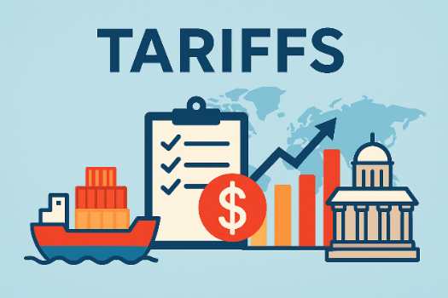
Tariffs are taxes that a country puts on things coming in from other countries. When a tariff is put on a thing, the price of that thing usually goes up. Governments use tariffs for several reasons. First, tariffs help keep local stores safe. If foreign things become more expensive because of tariffs, people might buy local things instead. Second, tariffs can help a country get money. The taxes taken from tariffs go to the government.
However, tariffs can also bring problems. When one country puts tariffs on another country's things, the second country might do the same back. This can start what is called a "trade fight." In a trade fight, both countries keep putting more tariffs, making things more expensive for everyone. This can hurt stores and people in both countries.
Tariffs can also change how countries get along. They might make it harder for countries to work together on other big things. Some people think that free trade without tariffs is better for the world market. They say it lets countries do what they are best at, which can lead to better ways to make things and lower prices.
In these years, tariffs have been an important thing in how countries work with each other. Some countries have made tariffs higher to keep their work safe, while others have tried to make them lower through trade talks. Knowing how tariffs work is important for knowing the world market.

17. (A) What is a tariff according to the passage?
(A) A tax on imported goods (B) A gift between countries
(C) A type of business (D) A trade agreement

18. (B) According to the passage, why do governments use tariffs?
(A) To make friends with other countries (B) To protect local businesses and earn money
(C) To start trade wars (D) To lower the prices of foreign goods

第3頁/共6頁

19. (C) What is a "trade war" as mentioned in the passage?
(A) A physical fight between countries (B) A competition to sell the most products
(C) When countries keep adding tariffs on each other's goods
(D) A way to make international trade easier

20. (C) According to the passage, how might tariffs affect relationships between countries?
(A) They always improve international relationships.
(B) They have no effect on international relationships.
(C) They might make cooperation on other issues more difficult.
(D) They always lead to better trade agreements.

21. (C) What do some experts believe about free trade without tariffs?
(A) It is dangerous for the world economy (B) It leads to higher prices
(C) It is better for the world economy (D) It is impossible to achieve

Earthquakes and Plate Movements
Earthquakes are one of nature's most powerful things. They can shake the ground, make buildings fall, and cause big sea waves. But what causes earthquakes? To understand this, we need to know about moving plates.
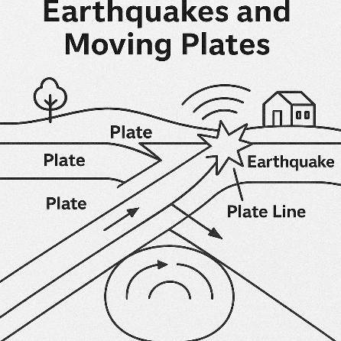
The Earth's outside part is made of big pieces called plates. These plates are always moving, though very slowly. Most earthquakes happen along the edges of these plates, called plate lines. When plates push each other, pull away, or slide past each other, they can get stuck. When they breakfree, energy is sent out as waves. These waves shake the ground, and that is what we feel as an earthquake.
Scientists check earthquakes using a number tool called the Richter scale. Each step on the scale means the shaking is ten times stronger. For example, a size 6 earthquake is ten times stronger than a size 5 earthquake. Most earthquakes are small and can barely be felt. But big earthquakes can cause serious damage and people can get hurt or die.

Some parts of the world have more earthquakes than others. The Pacific Ring of Fire, which goes around the Pacific Ocean, has about 90% of the world’s

第4頁/共6頁
earthquakes. Places like Japan, Chile, and the west part of the United States have many earthquakes because they are near plate lines.
Knowing about earthquakes and moving plates helps scientists guess where earthquakes might happen, but they still can’t tell when they will come. This helps people get ready by building stronger buildings and having plans for help.
22. (B) What is the main cause of earthquakes according to the reading?
(A) Big sea waves (B) The movement of plates
(C) Building work (D) A tool to check shaking
23. (B) Where do most earthquakes happen?
(A) In the middle of plates (B) Along plate lines
(C) In the Pacific Ocean (D) In places with bad buildings
24. (C) How much stronger is a size 7 earthquake than a size 5 earthquake?
(A) 2 times stronger (B) 7 times stronger (C) 100 times stronger (D) 700 times stronger
25. (B) Which place has about 90% of the world’s earthquakes?
(A) The Atlantic Ocean (B) The Pacific Ring of Fire (C) The west of the USA (D) Japan and Chile
26. (C) What can scientists guess about earthquakes?
(A) When earthquakes will happen (B) The size of future earthquakes
(C) Where earthquakes might happen (D) How to stop earthquakes

AI in Our Daily Lives

AI, or Artificial Intelligence, is changing how we live and work. AI means computer systems that can do jobs that usually need human thinking. These jobs include understanding words, knowing pictures, making choices, and learning from past things. AI is already part of our daily life.

第5頁/共6頁

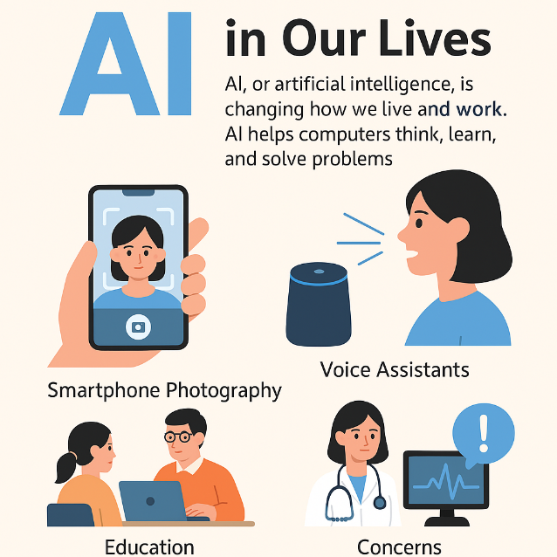
When you use a phone to take a picture, AI helps the camera find faces and change settings for a better picture. When you ask a voice helper like Siri a question, AI helps know your words and find the things you need. Movie or music apps use AI to show movies or songs you may like from what you have seen or heard before.

At school, AI can help give learning that fits each person. It can change for each student and give more help when needed. At the hospital, AI can help doctors find sick people by looking at pictures or health information. It can even guess health problems before they get bad.

But AI also brings problems. Some people worry about safety when AI uses personal things. Others worry that work may be lost as AI does some jobs. People also ask who is wrong if AI makes a mistake or causes a problem. As AI gets better, it will be a bigger part of our life. Knowing how AI works and its good and bad sides is important. By making smart choices about AI, we can help it be good for everyone.

27. (C) What does AI mean in the reading?

(A) Automatic Information (B) Advanced Internet

(C) Artificial Intelligence (D) Automatic Teaching

28. (C) Which is NOT something AI can do in the reading?
(A) Know words (B) Know pictures

(C) Heal every sick person (D) Learn from past things

29. (B) How does AI help with phone pictures?
(A) It takes the picture for you (B) It finds faces and changes settings

(C) It puts pictures on the Internet (D) It prints the pictures

30. (C) What is one thing people worry about AI?
(A) It costs too much (B) It is too slow

(C) It may take some jobs (D) It cannot hear people

