109-2 Gr.9 Basketball Skills Test Worksheet

Class: Number: Name:
- Test Form 測驗表格
      - Oral Test:
- Test1:
(1)Teacher: What are you going to do for the basketball test?
(2)Student:

- Skills Test:
- Teacher: “Are you ready for the test?”
- Student: “Yes, I’m ready.”/ “I’m ready!”
- Teacher: “Start!”/ “Ready, go!”

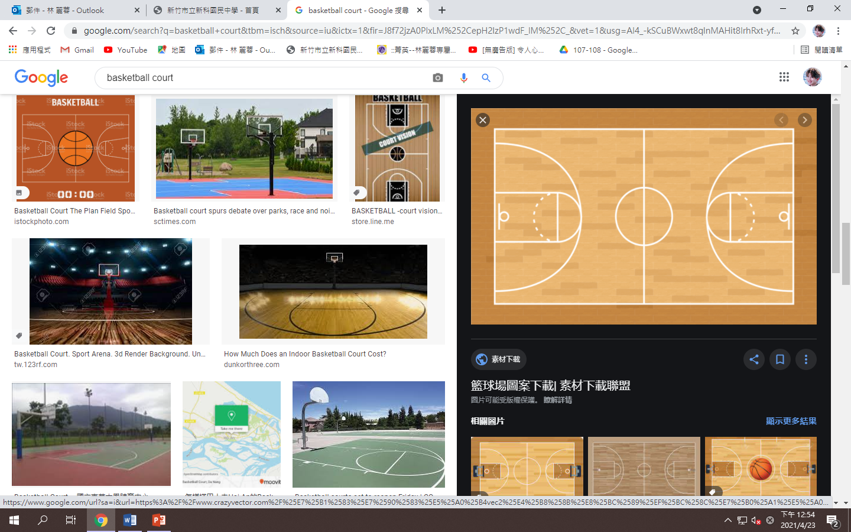
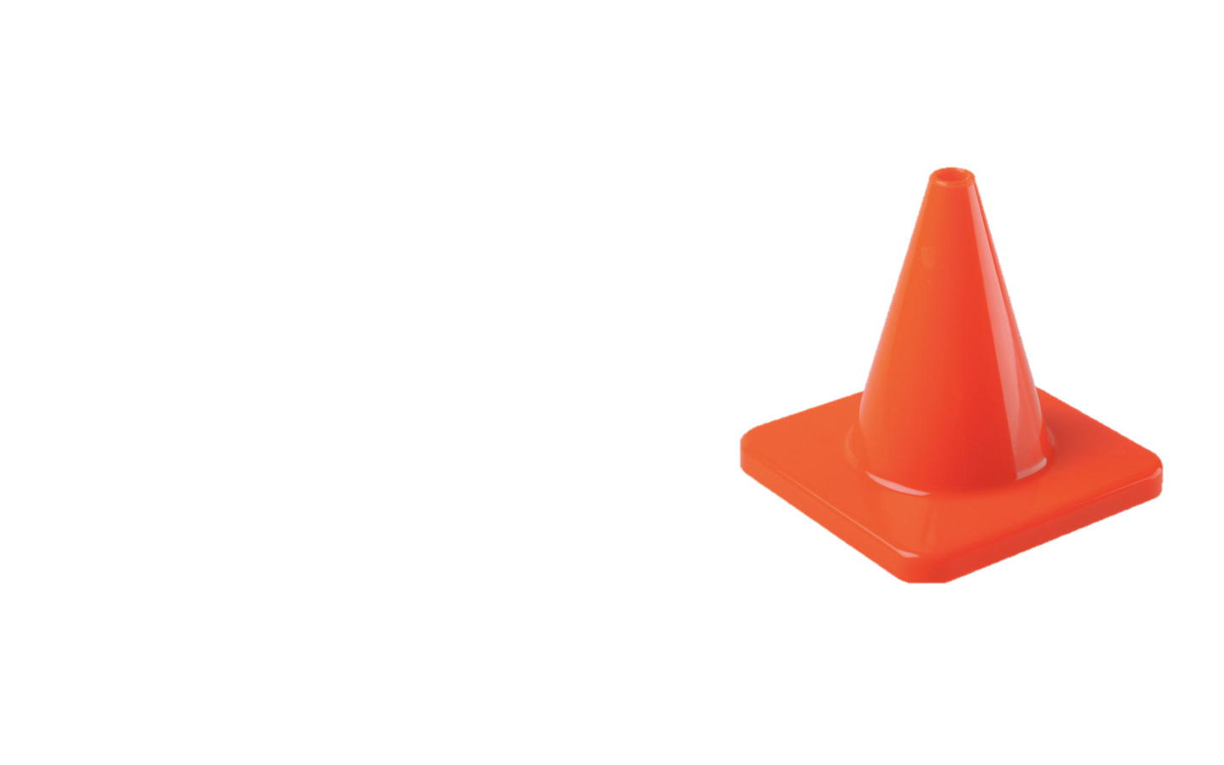

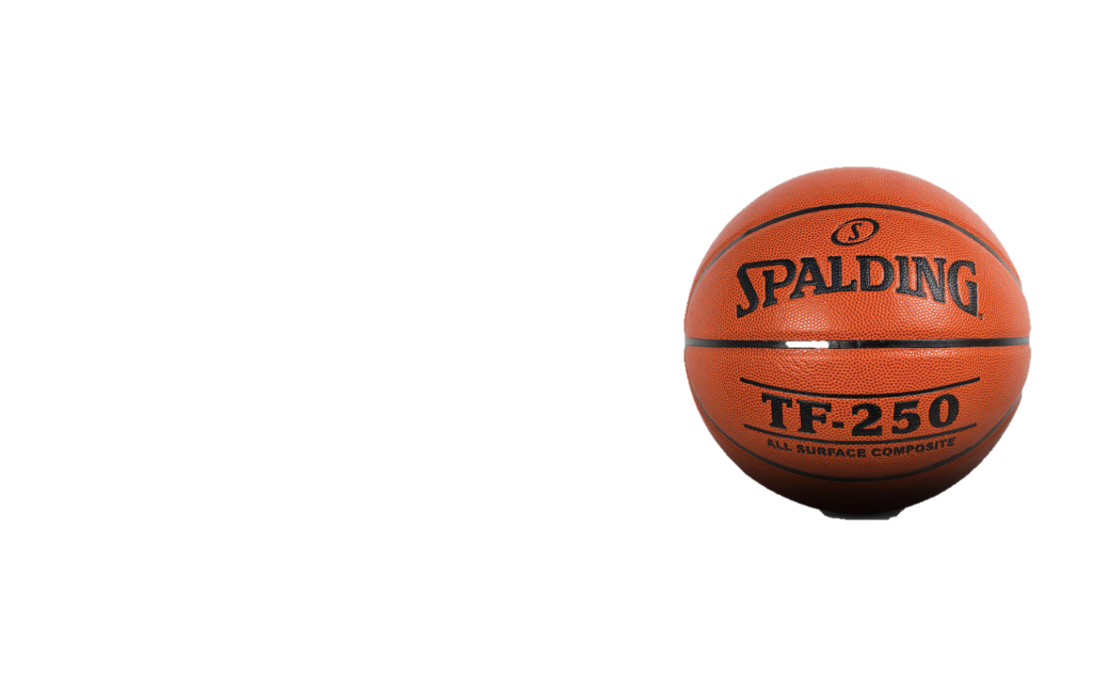
- Exam Set-up

- Grading for English Oral 英文口說分數評分標準:
Grading / Category | A | B | C
Basketball  test | - “I will dribble between the cones.”  我將會在角錐中運球  - “I will do a bounce pass to the teacher.”  我將會傳彈地球給老師  3.”I will catch the ball and do a lay-up.”  我將會接球然後做上籃動作  - “I will run back with dribbling to do a jump shot.”  我將會運球和跑回來做跳投。 | - “Dribble between cones”在角錐中運球  - “Bounce pass to the teacher.”  彈地傳球給老師  - “Catch the ball and Lay-up”接球和上籃  - “Run back, do a jump shot”  跑回來,做跳投 | 1.“Dribble”運球  2.“Bounce pass”  彈地傳球  3. “Lay-up”上籃  4. “Jump Shot”跳投

- Score Sheet評分表:
 | Skills | Learning | A | B | C | Score
 | Skills | Learning | 100 | 90 | 80 | Score
1 | 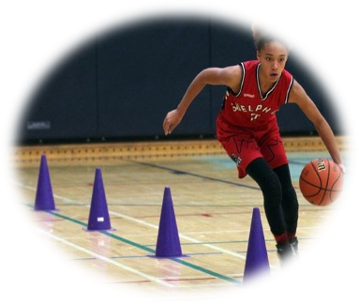  Basketball Test | Oral
1 |  | Skills
 |  |  | Total Points

- Score Level Description 分數等級說明
1 | Oral | A-100 | 做動作前，能夠清楚的用英文說出，教師所要你做的技能。  A student can say the skill’s movement in English that he/she is going to do prior to doing it. EX：I will dribble between the cones、I will bounce pass the ball to teacher.
1 | Oral | B-90 | 做動作前，能說出動作的關鍵字。  A student can say the keywords of the skills in English that he/she is going to do prior to doing it. EX：Dribble Between cones 、Bounce pass to teacher.
1 | Oral | C-80 | 做動作前，中師用英文及中文幫助學生。  A student says the keywords of the motion in English that he/she is going to do with the help of the teacher prior to doing it.  EX：Dribble、bounce pass
2 | Skill | A-100 | 優秀!能正確做出教師所說的技能動作(Boys: 15secs-20secs; Girls: 25secs-30secs)。  Awesome!You can correctly do the skill that the teacher asks you to do and complete the number of repetitions needed.
2 | Skill | B-90 | 普通。能正確做出教師所說的技能動作(Boys: 21secs-30secs; Girls: 31secs-40secs.)。  Average! You can correctly do the skill that the teacher asks you to do but needs practice and consistency.
2 | Skill | C-80 | 待加強!能正確做出教師所說的技能動作(Boys:31secs-40secs ; Girls: 41secs-50secs)。  Poor! Sometimes, you can correctly do the skill that the teacher asks you to do.

